1.Top view:

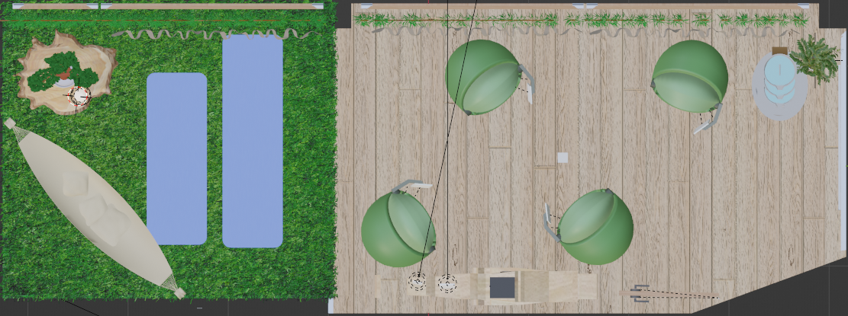

Resized top view:

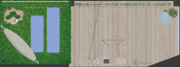

Green ratio calculated:

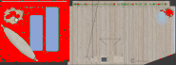

Similar pixels: 2857, Total pixels: 12765

Green ratio: 0.2238

PPM: 529

area: 5.4007 vs 24.13

2.Side view:

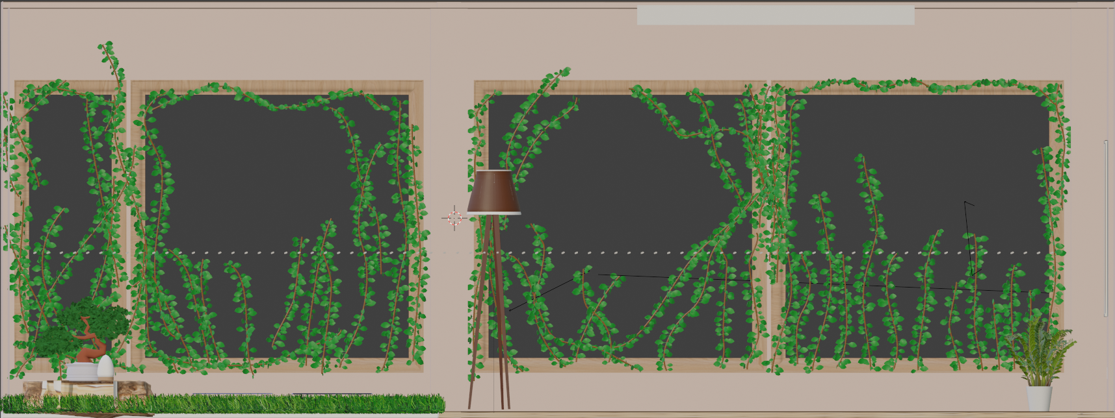

Resized:

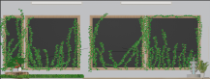

Calculated:

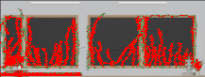

Similar pixels: 3203, Total pixels: 17794

Green ratio: 0.1800

PPM: 718.1

area: 4.46 vs 24.779

3.Side view:

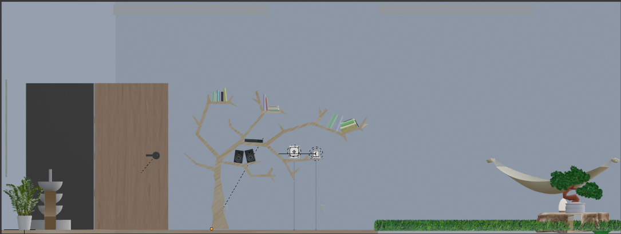

Resized:

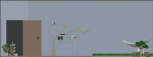

Calculated:



Similar pixels: 603, Total pixels: 17794

Green ratio: 0.0339

PPM: 718.1

area: 0.839 vs 24.779

4.Bottom view:

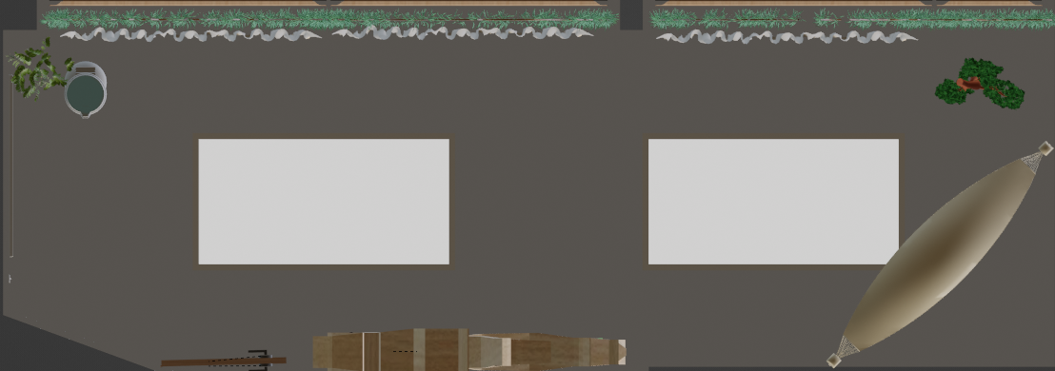

Resized:

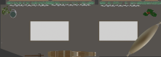

Calculated:



Similar pixels: 1344, Total pixels: 17238

Green ratio: 0.0780

PPM: 529

area: 2.54 vs 25.86

5. Side view:

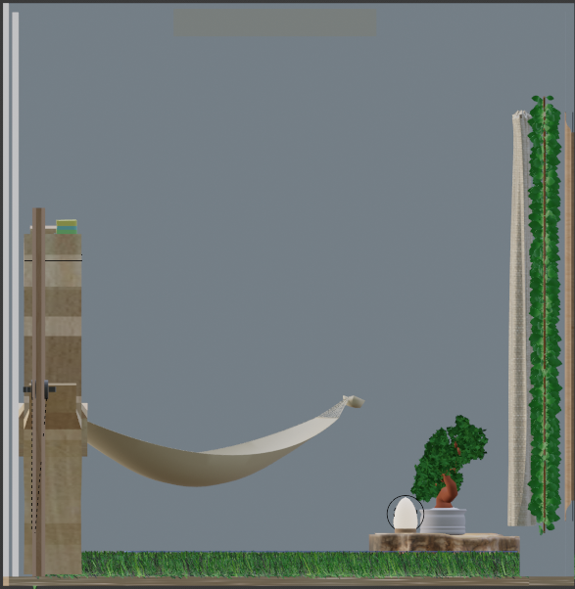

Resized:

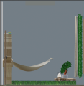

Calculated:

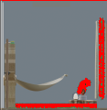

Similar pixels: 1082, Total pixels: 14040

Green ratio: 0.0771

PPM: 1512.35

Area: 0.7154 vs 9.284

6.Side view:

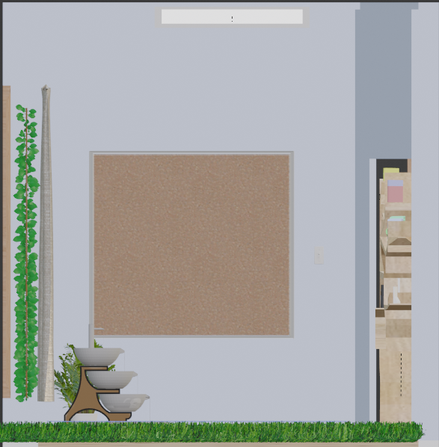

Resized:

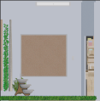

Calculated:

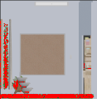

Similar pixels: 887, Total pixels: 13923

Green ratio: 0.0637

PPM: 1512.35

Area: 0.586 vs 9.206

Conclusion:

Total green area:

14.5411m^2

Total area:

118.038m^2

Green ratio:

0.12319